**PROJECTDESIGNPHASE-1-SOLUTIONARCHITECTURE**

|  |  |
| --- | --- |
| **DATE** | **4NOV 2022** |
| **TEAMID** | **PNT2022TMID26869** |
| **PROJECTNAME** | **SMARTWASTEMANAGEMENTSYSTEMFORMETROPOLITANCITIES** |

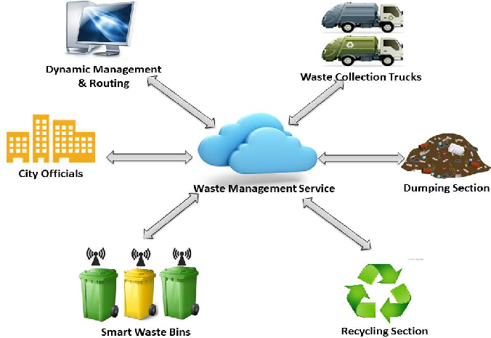



**ABSTRACT:**

The Internet of Things (IoT) is a concept in which surrounding objects are connected through wired and wireless networks without user intervention. In the field of IoT, the objects communicate and exchange information to provide advanced intelligent services for users.

This project deals with the problem of waste management in smart cities, where the garbage collection system is not optimized. This project enables the organizations to meet their needs of smart garbage management systems. This system allows the user to know the fill level of each garbage bin in a locality or city at all times, to give a cost-effective and time-saving route to the truck drivers.